EMERGENCY Call to Prayer NOW
August 20th, 2020
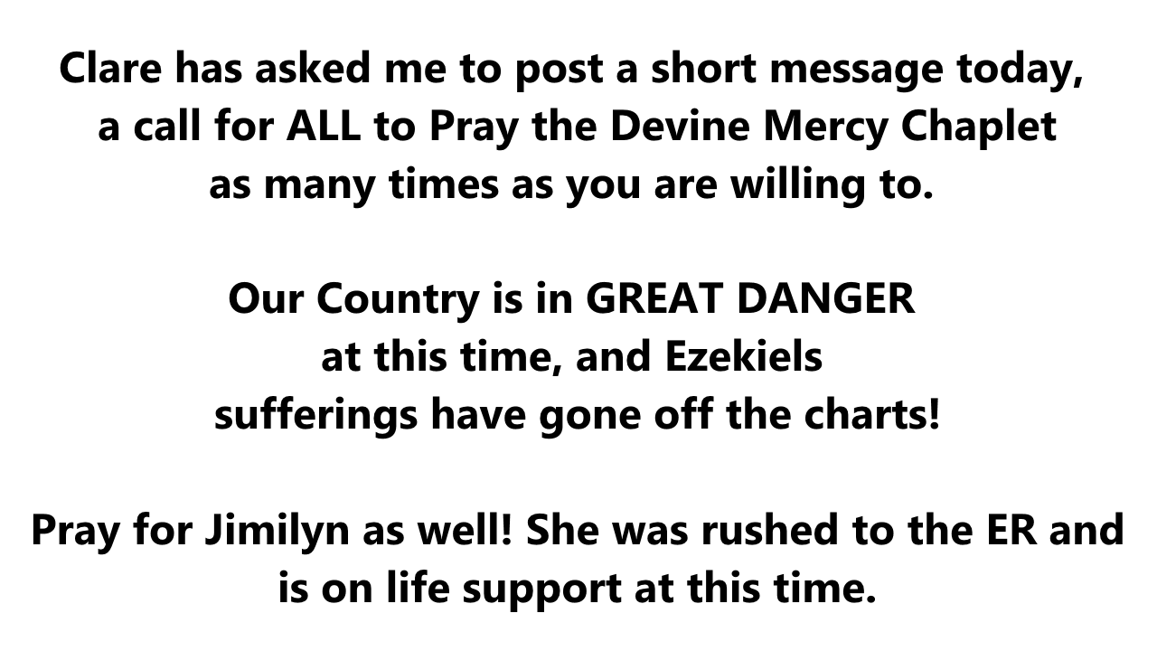
Clare has asked me to post a short message today, a call for ALL to Pray the Devine Mercy Chaplet as many times as you are willing to.

Our Country is in GREAT DANGER at this time, and Ezekiel’s sufferings have gone off the charts!

Pray for Jimilyn as well! She was rushed to the ER and is on life support at this time.

